A CRM APPLICATION FOR THECHAISHOP&CO
6. Project Testing Phase

Project & Team Details
Attribute | Details
Project Title | A CRM Application for TheChaiShop&Co
Domain | Cloud Computing / Salesforce Administration
Platform | Salesforce Lightning Developer Edition
Institution | PS PT MGR Government Arts & Science College, Sirkali, Puthur - 609108 (College Code: ANM403)
Submission Portal | SkillWallet
Team Leader | PRITHIVIRAJ R - (Reg. No. 24134031802521033)
Member 2 | Dharun Mass - (Reg. No. 24134031802521016)
Member 3 | Ajan A - (Reg. No. 24134031802521006)
Member 4 | Sanjai D - (Reg. No. 24134031802521041)
Member 5 | Vigneswaran C - (Reg. No. 24134031802521055)

1. INTRODUCTION

1.1 Project Overview
The project "A CRM Application for TheChaiShop&Co" focuses on testing and validating the Salesforce Lightning CRM system built to streamline retail transactions, online dispatches, and corporate accounts. The testing phase rigorously validates object relationships, data integrity rules, automated formula calculations, scheduled background flows, and analytical dashboards.

1.2 Purpose
The primary objectives of the testing phase are:
- Verify Record Type selection modals for Online Order and Walk-In Order paths.
- Validate page layout field assignments based on distinct sales channels.
- Enforce data integrity through mandatory field validations and regex phone formatting.
- Confirm declarative formula calculation accuracy for order quantities and gross bills.
- Test schedule-triggered flows and automated birthday email alert execution.
- Ensure real-time reporting queries and dashboard visualization consistency.

2. TESTING PHASE

2.1 Functional Test Cases & Validation Results
TC ID | Test Scenario | Test Input / Action | Expected Result | Actual Result | Status
TC-01 | Record Type Selection Modal | Click "New" under Customer Accounts tab | A modal dialog prompts the user to select between Online Order and Walk-In Order | Modal displayed correctly; routed cleanly upon selection | PASS
TC-02 | Page Layout Field Rendering | Select "Walk-In Order" record type and click Next | Form loads dedicated Walk-In layout displaying Chai options, counter payment modes, and order fields | All mapped layout fields rendered correctly | PASS
TC-03 | Mandatory Validation Rule Enforcement | Attempt to click "Save" leaving required fields blank | System halts save and displays error: "We hit a snag. Review the following fields" | Save was blocked; missing fields highlighted in red | PASS
TC-04 | Phone Number Regex Validation | Enter invalid phone number (e.g., non-numeric or < 10 digits) | System blocks save with error: "The phone number must consist of exactly 10 digits" | Validation rule fired; invalid entries blocked | PASS
TC-05 | Billing Formula Calculation Accuracy | Select items: "Platinum Tea Powder" (175) + "Single Tea" (50) | Formula field automatically computes Order Quantity = 1 and Total Bill = Rs.225.00 | Total Bill calculated dynamically to Rs.225.00 | PASS
TC-06 | Scheduled Birthday Flow Execution | Customer record where Date of Birth matches current system date (Date_of_Birthday_is_today__c = True) | Schedule-Triggered Flow triggers "Happy Birthday email alert" with promo code [HBDAY50] | Email alert executed successfully | PASS
TC-07 | Dashboard Dynamic Metric Refresh | Create new customer transaction and click "Refresh" on Dashboard | Visual charts update sales aggregations and metric tallies in real time | Bar Chart and Donut Chart refreshed live | PASS

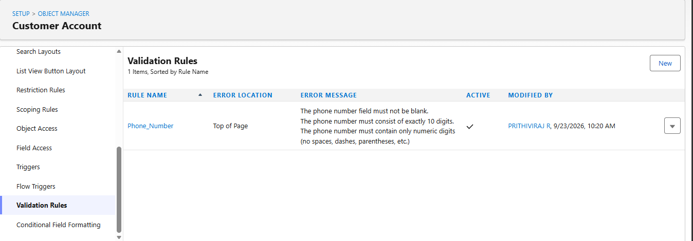

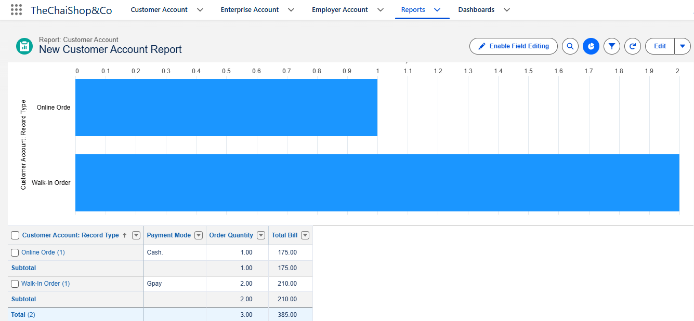

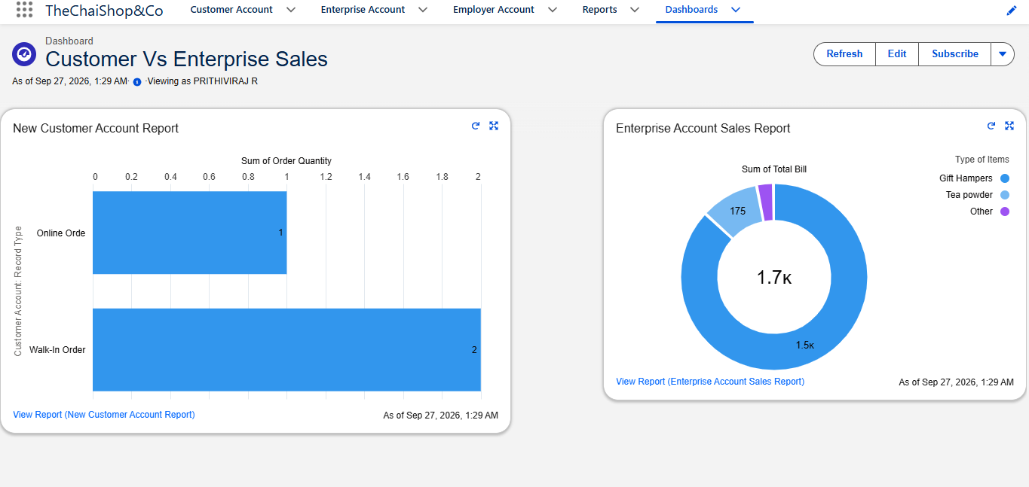

2.2 Testing Summary & Conclusion
All defined test cases (TC-01 through TC-07) executed successfully with a 100% pass rate. The custom validation rules enforce strict data integrity, declarative formula engines eliminate counter calculation blunders, and the automated flows and executive dashboards operate reliably in real-time. The application is verified to be robust, secure, and fully operational for retail deployment.

